**GATEBOX: DETAILED HARDWARE INSTRUCTIONS**

By Shafeeq Rabbani

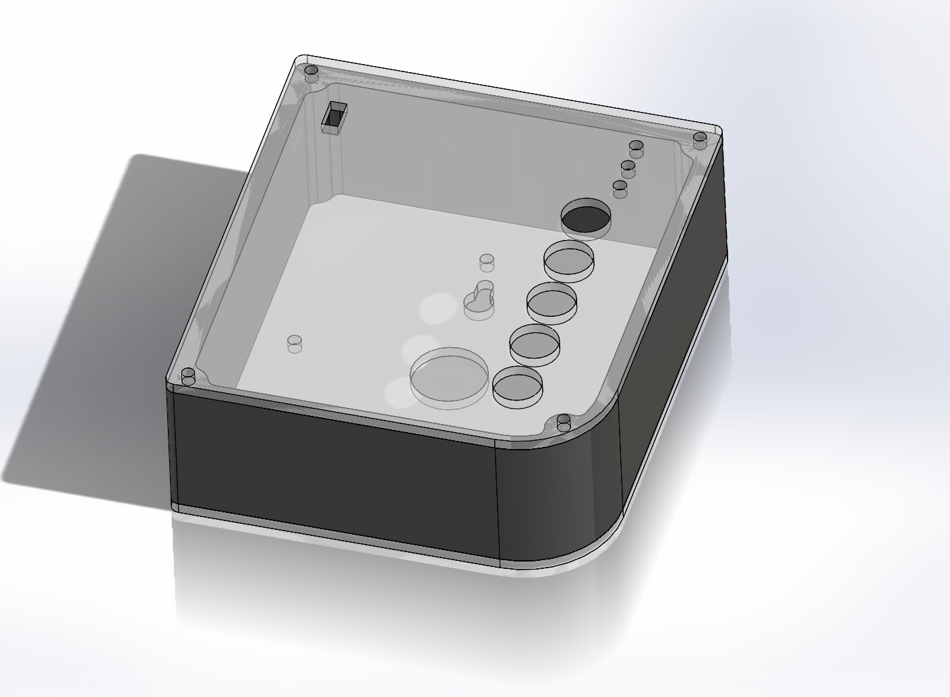

Contents

Introduction 2

Pinout for Relays, Push Buttons, LEDs and Slide Switch 2

Final Steps: 4

## Introduction

As the PCB machine printer does most of the job when it comes to hardware instructions, this section is quite straight forward. Currently, there isn’t a complete version of the circuit. There is one that is almost complete: Would appreciate it if someone could replace the two solid state relays in the “PCB with nRF/Dual Relay” folder, with 4 mechanical relays (as shown in PCB V7 board.PNG and PCB V7 Schematic.PNG in Simplified Schematic folder) and re-route all the wires and push the .brd and .sch files. The Detailed Schematic/nRF8001 folder also contains .sch and .brd files of the nRF8001 chip from Nordic Semiconductors and Adafruit, the manufacturers of the nRF8001 chip and the Bluetooth Low Energy module respectively.

## Pinout for Relays, Push Buttons, LEDs and Slide Switch

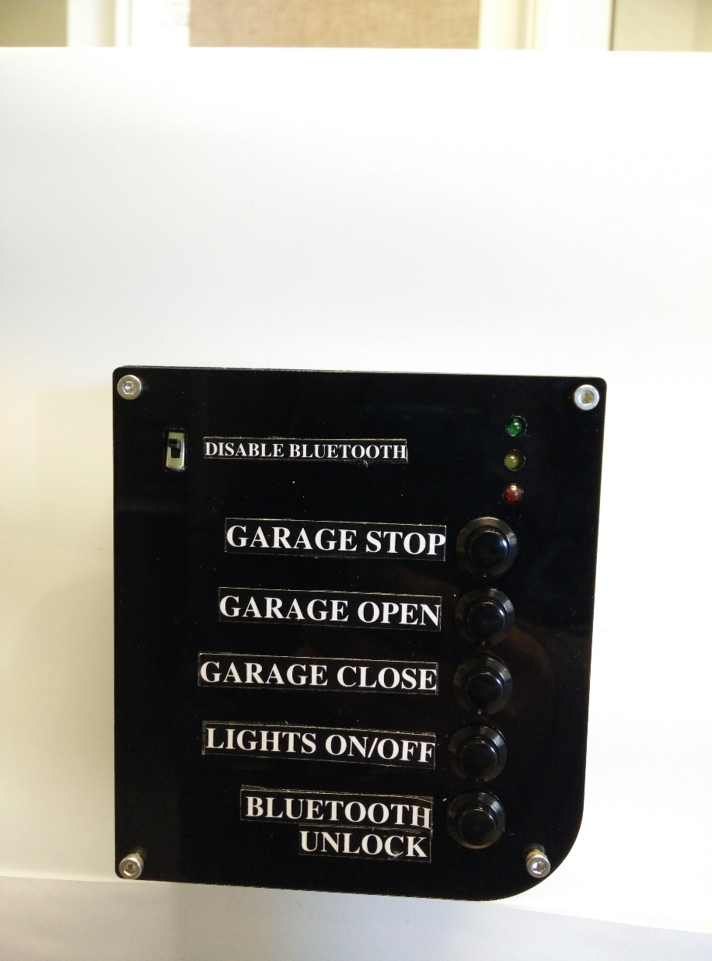

Just for reference, here are the pinouts.

The Relays and LEDs are operated by output pins and the Push Buttons are operated by input pins.

The following table shows which pin corresponds to what function in the Arduino code “ConnectedCar” and “ConnectedCarTest”. Solder these connections or use header pins from the Arduino to the relay circuit board.

**Output pins**

|  |  |  |
| --- | --- | --- |
| **Component** | **Function** | **Pin Number** |
| Relays | Garage Stop | 7 |
| Garage Open | 4 |
| Garage Close | 5 |
| Lights On/Off | 10 |
| LEDs | LED: Red | 3 |
| LED: Green | A5 |
| LED: Yellow | 2 |

**Input pins**

|  |  |  |
| --- | --- | --- |
| **Component** | **Function** | **Pin Number** |
| Push Button | Garage Stop | A0 |
| Garage Open | A1 |
| Garage Close | A2 |
| Lights On/Off | A3 |
| Bluetooth Unlock | A4 |
| Slide Switch | Disable Bluetooth | This switch must be on the 5V wire connection between the Arduino and the Bluetooth Low Energy Chip. Hence, “Disable Bluetooth” turns of the power itself to the Bluetooth Chip. |

If you are having trouble identifying which pin on the Atmega328p corresponds which pin number, use this diagram below:

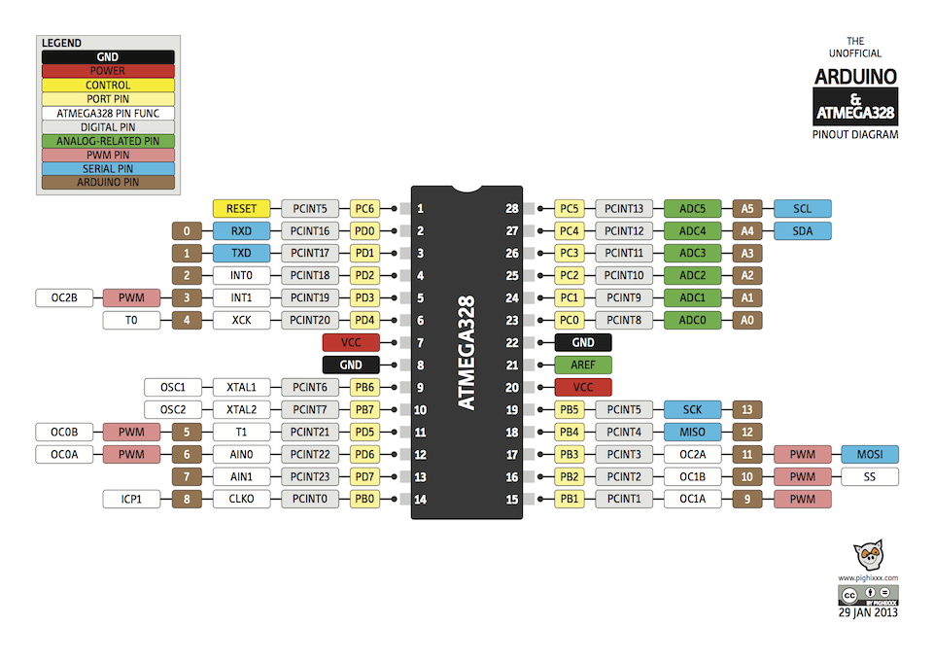

## Final Steps:

Connect wires from pre-existing garage door openers into the terminal blocks. Refer to the Garage Door Openers on Market (Manuals) folder to get an idea of how majority of the garage door openers on the market work. Do the same for lights. As this involves working with the mains, this task must be carried out with the aid of a professional certified electrician.

Connect the 5V dc jack onto the Arduino to power it. You can now insert the electronics into the GateBox panel and close the seal to power it up.

Your GateBox panel is now ready.